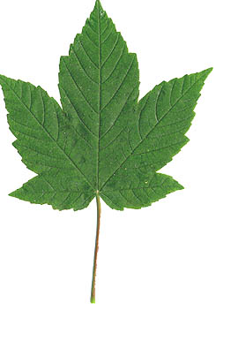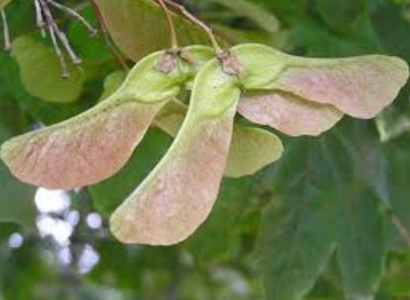

WWRC is urging horse owners to stay vigilant and keep their horses and ponies away from Sycamore following the tragic death of two young horses belonging to one of our members.
Sycamore trees don’t have to be situated in the horse/pony’s fields the plant seeds can be scattered by wind and floodwater.

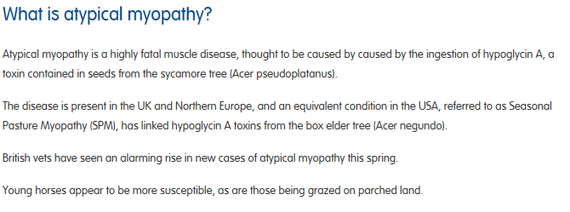
TOP TIPS
